Name: Kaodili Okwuaka

Email: [kokwuak@rockets.utoledo.edu](mailto:kokwuak@rockets.utoledo.edu)

Project 1

September 13, 2017.

**Part A**

char c1;

c1 = getChoice();

switch (c1) {

case ‘a’, case ‘A’: processOptionA(); break;

case ‘I’, case ‘I’: processOptionI(); break;

case ‘w’, case ‘W’: processOptionW(); break;

default : System.out.println("Not a valid choice \n");

}

**Part B**

1. OptionA() and optionI() are wrong ways to name a method
2. The print out command is wrong
3. Wrong alignment
4. Too much unnecessary white spacing in the program.
5. The quotation mark following the print out statement is outside the parenthesis but it should be inside.

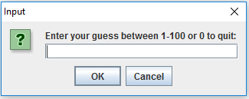

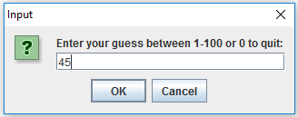

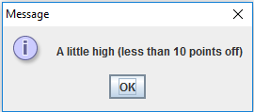

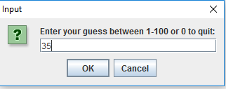

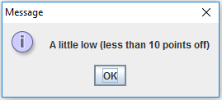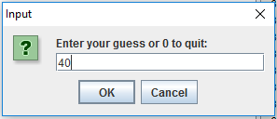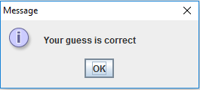

Question 3.

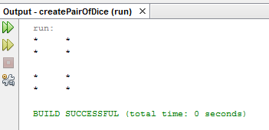

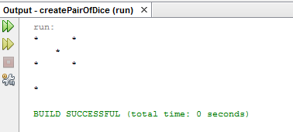

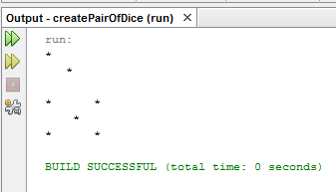

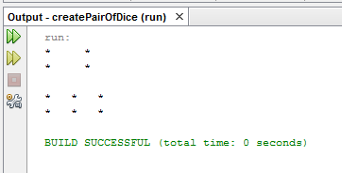

Question 4.

